**CE101 Engineering Drawing July- Nov 2019**

**Indian Institute of Technology Guwahati**

**Lab Sheet-9 Development of Surfaces Friday Afternoon**

**Full Marks: 100 Date:25.10.2019**

1. Draw the development of the complete surface of a hexagonal prism of base 30 mm and height 70 mm along its FV & TV. (15 Marks)
2. Draw the development of the lateral surfaces of a cube whose front view is shown in figure below. (35 Marks)

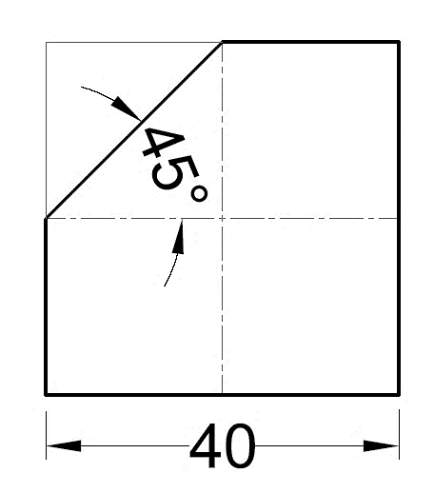

1. A circular hole of largest size is cut in a semi- circular metal sheet of diameter 100 mm. The sheet is wrapped to form a cone resting on its base on the HP. Draw the projections of the cone with the circle marked on it. (50 Marks)